|  |  |
| --- | --- |
|  | **2021** |
|  | ARMGHAN AHMAD  20P-0183 |

|  |
| --- |
| **[OOP LAB ASSIGNMENT 1]** |
|  |

## QUESTION 1:

//calculator with the help of switch statement

#include<iostream>

using namespace std;

int main ()

{

int A,B;

char ope;

cout <<"Enter two number A and B:\n";

cin >>A>>B;

cout <<"Enter operation from (+,-,*,/,\'%\') you want to perform:\t";

cin >> ope;

switch (ope)

{

case '+':

{

cout <<A<<" + "<<B<<" = "<<A+B<<endl;

break;

}

case '-':

{

cout <<A<<" - "<<B<<" = "<<A-B<<endl;

break;

}

case '*':

{

cout <<A<<" * "<<B<<" = "<<A*B<<endl;

break;

}

case '/':

{

cout <<A<<" / "<<B<<" = "<<float(A)/float(B)<<endl;

break;

}

case '%':

{

cout <<"remainder of A and B = "<<A%B<<endl;

break;

}

default:

{

cout <<"enter correct operation. You enter worng operation! "<<endl;

}

}

return 0;

}

Output:

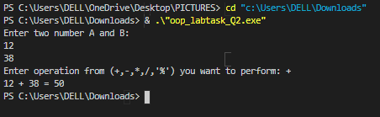

## QUESTION 2:

#include <iostream>

using namespace std;

int main ()

{

float S ,D;

cout << "enter your salary :\t";

cin >>S;

if (S < 10000)

{

cout <<"Your salary is less then 10,000 so there is no deduction.\n your actual salary = "<<S<<endl;

}

else if (S >= 10000 && S <= 20000 )

{

D=S-1000;

cout <<"Your salary = "<<D<<endl;

}

else

{

D =S*0.7;

cout <<"your salary is =" << S-D << endl;

}

return 0;

}

Output:

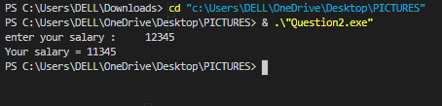

## QUESTION 3:

#include <iostream>

using namespace std;

int main ()

{

int number ;

cout << "Enter a number :\t";

cin >> number;

if (number % 2 == 0)

{

cout <<number <<" is even ";

}

else

{

cout<<number<< " is odd "<<endl;

}

return 0;

}

Output:

